HOSPITAL MANAGEMENT SYSTEM
(UML DIAGRAM)

table storing :
- the name it
- address
- departments
functions to :
- get info
- Edit the details
- Get departments

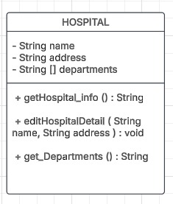

table storing :
- User id
- User name
- Password
- Email
- role
functions to :
- Login to system
- Logout
- Update user info
- Reset password
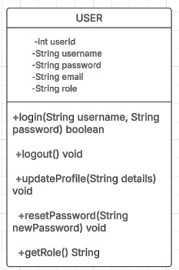

table storing :
- User id
- User name
- Password
- Email
- role
functions to :
- Login to system
- Logout
- Update user info
- Reset password
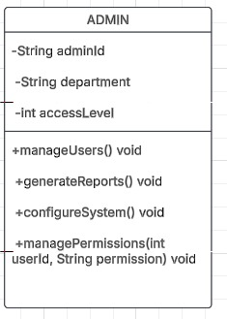

table storing :
- doctor id
- Doctor’s specialization
- Doctor’s schedule
- Experience
functions to :
- Veiw doctors appointments
- Update appointments
- Medicine prescribed
- Access to previous medical record
- Update the pateint status
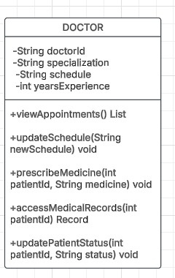

table storing :
- patient id
- history
- Insurance
- Blood group
- allergies
functions to :
- Book appointment
- View history
- Updaterecord
- Get your appointments
- Request for medicine

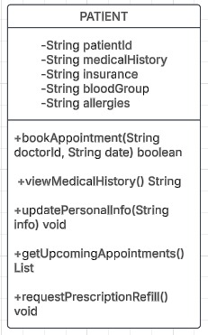

table storing :
- Appointment id
- Date of appointment
- Appointment status
- Appointment notes
functions to :
- Schedule appointment
- Cancel appointment
- reschedule
- Status of appointment

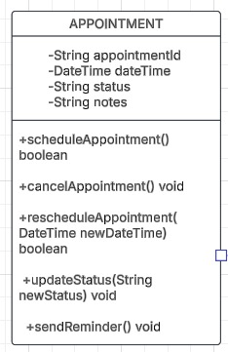

table storing :
- Chat id
- Time of chat
- Message content
- status
functions to :
- Send message
- Receive message
- Mark as read
- Delete the message

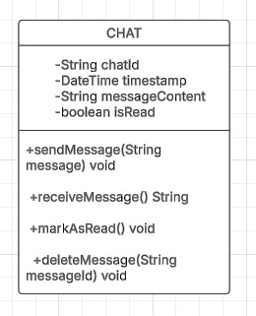

table storing :
- bill id
- amount
- Payment status
- Date of bill
functions to :
- Generate bill
- Process payment
- Update payment status

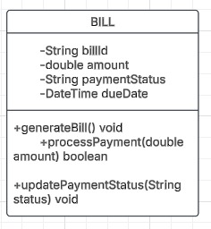

table storing :
- kit id
- Device type
- Reading
- Device active
- Reading time
functions to :
- Record reading
- Latest reading by kit
- Device status

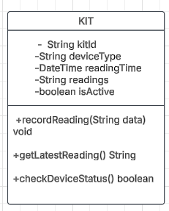

table storing :
- record id
- Breathing rate
- Blood pressure
- Heart rate
- Temprature
functions to :
- Update vitals
- Latest vitals
- Generate report

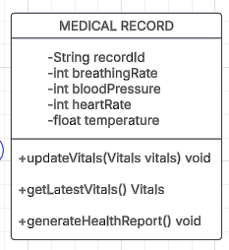

table storing :
- dept id
- Dept name
- Hod
- Staff count
functions to :
- Assign staff
- Get department staff
- updateinfo

